Case for Coverage of the National DPP Lifestyle Change Program: Presentation Outline
This Presentation Outline is to be used as a supplement alongside either the Presentation Template for Employers or the Presentation Template for Commercial Plans, which can be accessed on the Case for Coverage for Commercial Plans and Employers page of the Coverage Toolkit. This outline is organized based on the slide numbers of the presentation templates. It contains tips for presenting, and additional information, statistics, and graphics that can supplement the content in the presentation templates.

Slide 1: Title Slide

To-Do

Insert organization logo, title, and presenter name

Slide 2: Outline of Presentation

Presentation Tips
- Know your audience and focus on what matters most to them (e.g., costs, health outcomes, health equity, ease of program delivery, member/employee satisfaction, etc.)
- Use data-driven information that is up-to-date and credible. If possible, include state and local data specific to the organization and information from similar types of organizations as examples of implementation.

Additional Resources
Additional topics that could be included in this presentation can be found on the Case for Coverage for Commercial Plans and Employers page of the Coverage Toolkit.

Slides 3-9: Set the Stage: Prediabetes and Type 2 Diabetes

Presentation Tips
In the “Set the Stage” slides present the need for coverage of the National Diabetes Prevention Program (National DPP) lifestyle change program by describing the impact of prediabetes and type 2 diabetes on the organization and its members/employees.
Be sure to describe the issues that are relevant to the organization, including how their members/employees may be impacted by prediabetes and type 2 diabetes (such as disease incidence rates, absenteeism, costs of medication, and the burden of complications).
Add additional information including statistical data to your slides to make it more relevant to the organization and include local and state specific data (available below).

Additional Information for Setting the Stage

National Statistics
- According to CDC’s National Diabetes Statistics Report, 2020:
  - From 2013-2016, 34.5% of all US adults were estimated to have prediabetes
  - In 2018, 88 million US adults had prediabetes.
  - In 2018, 34.1 million adults in the U.S. had diabetes (both diagnosed and undiagnosed)
  - In 2018, 7.3 million adults had undiagnosed diabetes
  - In 2018, 26.9 million people of all ages—or 8.2% of the US population—had diagnosed diabetes
  - Diabetes was the 7th leading cause of death in the U.S. in 2017
- Diabetes in adults has tripled in the past two decades; it is estimated that 1 in 3 adults in the US could have diabetes by 2050.
- Diabetes is the costliest of the 155 most common diseases in the country, at $237 billion in direct medical costs and $90 billion in indirect costs (e.g., reduced productivity and absenteeism) in 2017—an increase of 60% from 2007.,
- Annual medical expenditures for people diagnosed with diabetes is $16,750 per year—2.3 times as much as those without diabetes.
- Diabetes doubles the risk of physical disability; adults with diabetes who are ≥50 years of age lose independence 6 to 7 years before their peers without diabetes.4

Additional Resources for Setting the Stage
Estimated prediabetes and diabetes rates for each state, as well as the direct and indirect costs of diabetes in each state, are available here. Additional state level data can found in the Diabetes State Burden Toolkit.
To find more information about the costs associated with type 2 diabetes, visit the Cost and Value page of the Coverage Toolkit.
For more information on the current prediabetes and type 2 diabetes rates in the United States, including rates broken down by age, gender, and ethnicity, see the National Diabetes Statistics Report, 2020.

Additional Graphics for Setting the Stage
More diabetes and prediabetes infographics produced by CDC can be found here. Additionally, the following graphics could also be added to a presentation:
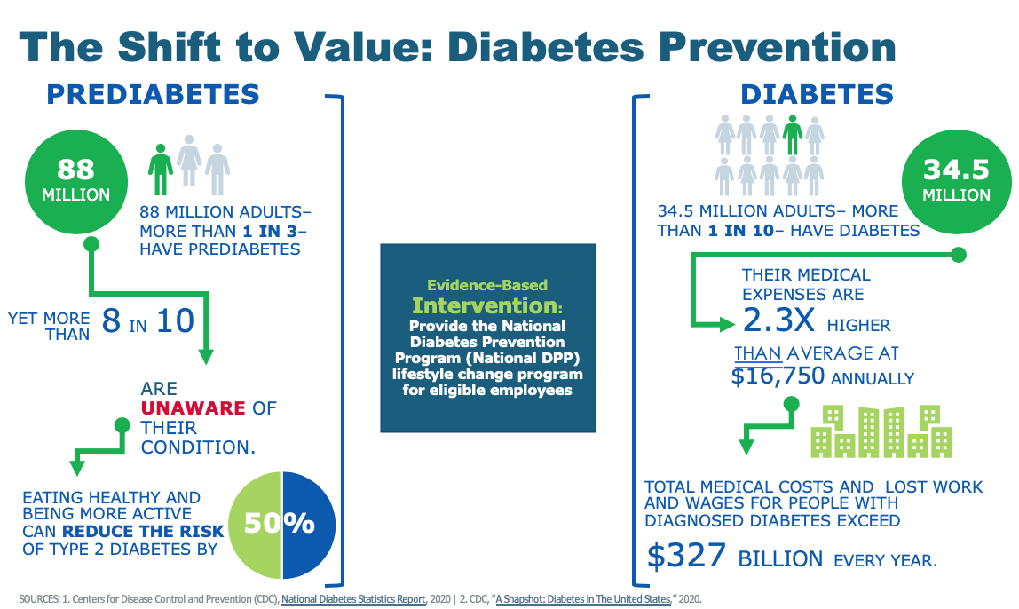

Slides 10-12: Present the Solution

To-Do
- Indicate whether the program is offered in other languages
- Insert locations in the local community offering the program or virtual delivery options

Presentation Tips
Explain how the National DPP lifestyle change program helps to address the issues described in the previous slides. Including overall ROI and VOI information from the Cost & Value page and calculators included in the Coverage Toolkit would be most appropriate here.

Additional Information and Statistics for Presenting the Solution
- About the National DPP lifestyle change program
  - Evidence-based, supported by National Institutes of Health (NIH) clinical trial
  - National effort with quality assurance through CDC’s Diabetes Prevention Recognition Program (DPRP)
  - Year-long, group-based program for adults focused on helping people lose 5% of their body weight through healthier eating and 150 minutes of physical exercise a week
  - Consists of 16 weekly sessions during the first six months and six monthly sessions during the second six months
  - Designed for people 18 years or older who have prediabetes or are at-risk for type 2 diabetes, but who do not already have diabetes
  - Program delivered in-person, online, through distance learning, or through a combination approach
  - Taught by trained lifestyle coaches (health professionals or non-licensed personnel)
  - Includes group support (recommended group size ranges between 10 and 25 participants but online groups may be larger)
  - Organizations offering the National DPP lifestyle change program can use a curriculum developed by CDC, develop their own curriculum and submit it to CDC for approval, or receive permission to use another organization’s curriculum as long as it is CDC approved
  - There are thousands of CDC-recognized organizations delivering the National DPP lifestyle change program across the 50 states and D.C.
- Benefits of the National DPP lifestyle change program
  - The National DPP is proven to reduce the risk of developing type 2 diabetes by 58% in adults (the risk of developing type 2 diabetes is reduced by 71% in adults over 60)
  - A reduction in rates of type 2 diabetes correlates to reduced medical claims/health care costs
  - Benefits extend beyond direct financial benefits to additional financial benefits such as better job performance, decreased absenteeism, increased job satisfaction, etc. (see the value on investment (VOI) graphic below)
- National DPP lifestyle change program participation eligibility
  - Be at least 18 years old, and
  - Be overweight (body mass index ≥25; ≥23 if Asian), and
  - Have no previous diagnosis of type 1 or type 2 diabetes, and
  - Have a blood test result in the prediabetes range within the past year:
    - Hemoglobin A1C: 5.7%–6.4%, or
    - Fasting plasma glucose: 100–125 mg/dL, or
    - Two-hour plasma glucose (after a 75 gm glucose load): 140–199 mg/dL, or
  - Be previously diagnosed with gestational diabetes, or
  - Score 5 or higher on the CDC/ADA Prediabetes Risk Test
- National DPP lifestyle change program coverage landscape
  - Covered nationally by Medicare; in an increasing number of states by Medicaid; and by many commercial plans, employers, and state and public employers

Additional Resources for Presenting the Solution
The Coverage Toolkit contains multiple pages that can be used to supplement slides on presenting the solution:
- The National Diabetes Prevention Program Overview page provides basic information on how the program is structured.
- The Evidence page contains multiple studies demonstrating the efficacy of the National DPP lifestyle change program, including evidence of efficacy when it is delivered online or through distance learning. This page also has studies demonstrating additional health benefits beyond the prevention of type 2 diabetes that result from the program.
- The Cost and Value page contains information on the return on investment (ROI) and VOI of the program, as well as multiple budget and project impact tools and calculators.
- The Participating Payers page provides a list of payers who are currently covering the National DPP lifestyle change program, including commercial health plans, employers, state-public employee coverage, state Medicaid coverage, and Medicare coverage. The page contains multiple visuals and maps that can be copied into a presentation.

Additional Graphics for Presenting the Solution
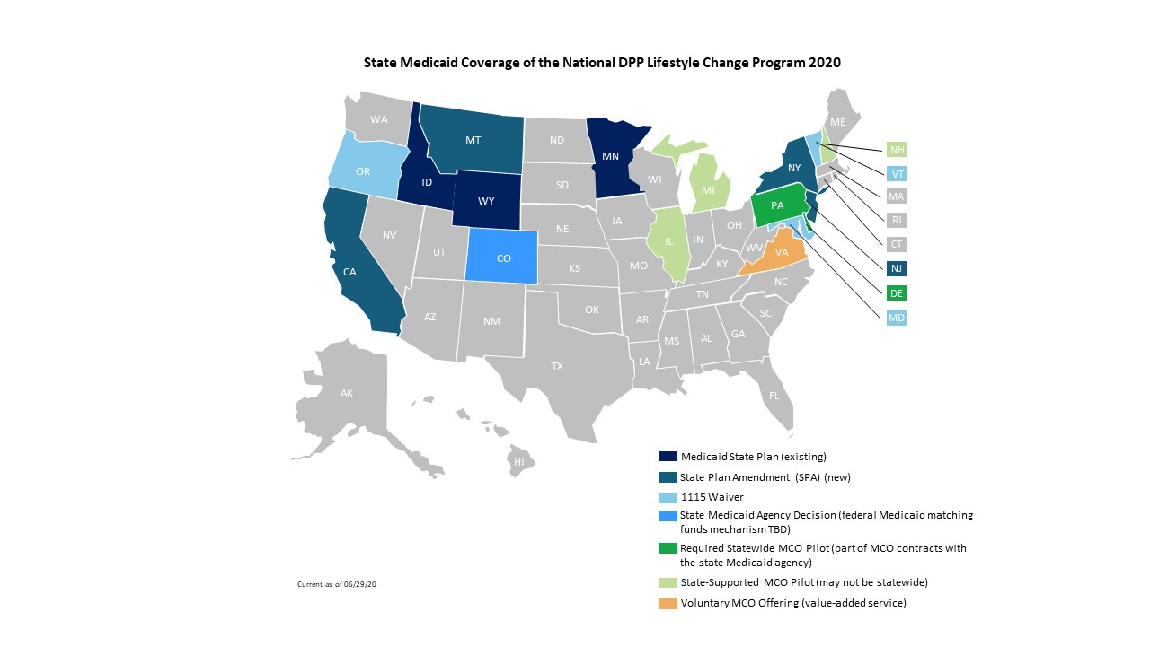
For the most up-to-date version of this map and other payer maps, visit the Participating Payers page of the Coverage Toolkit.

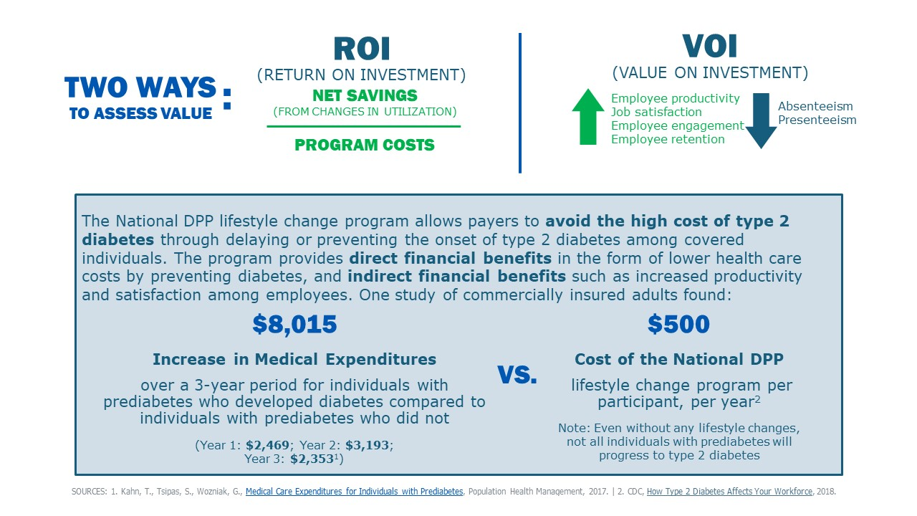

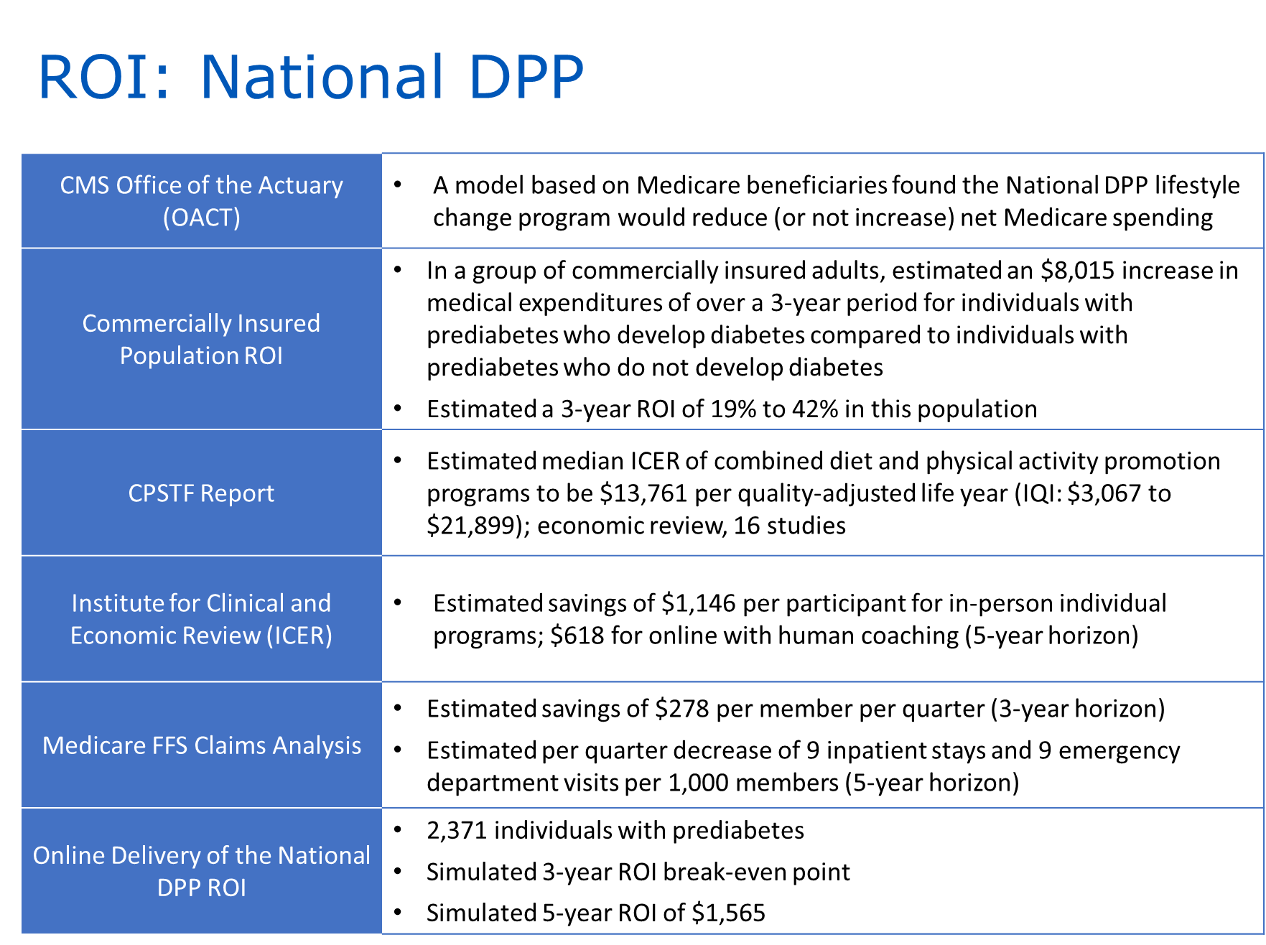
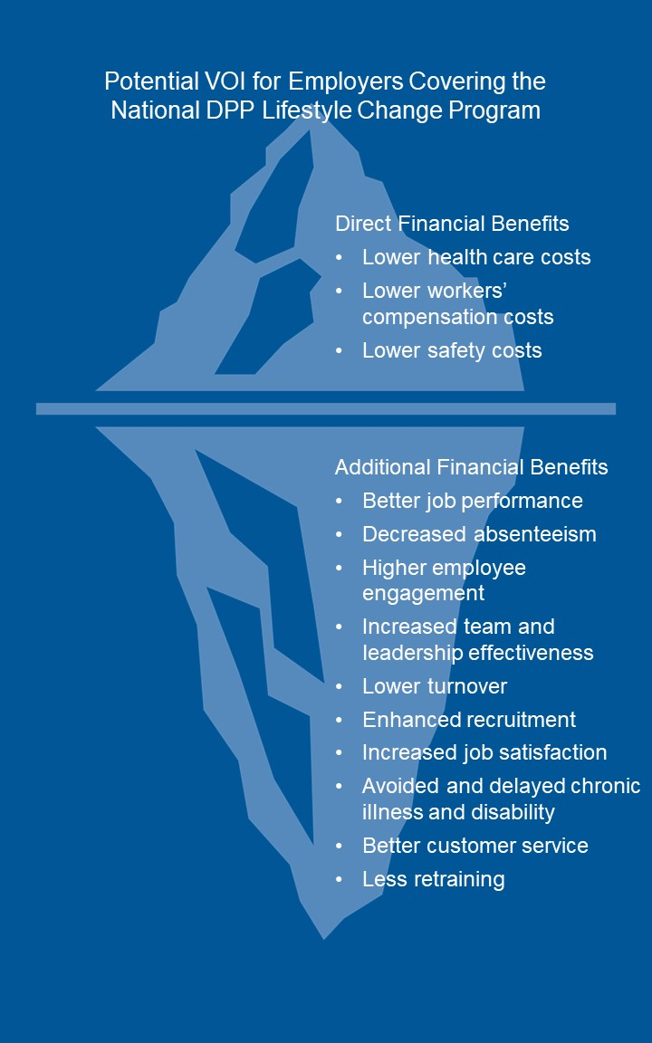
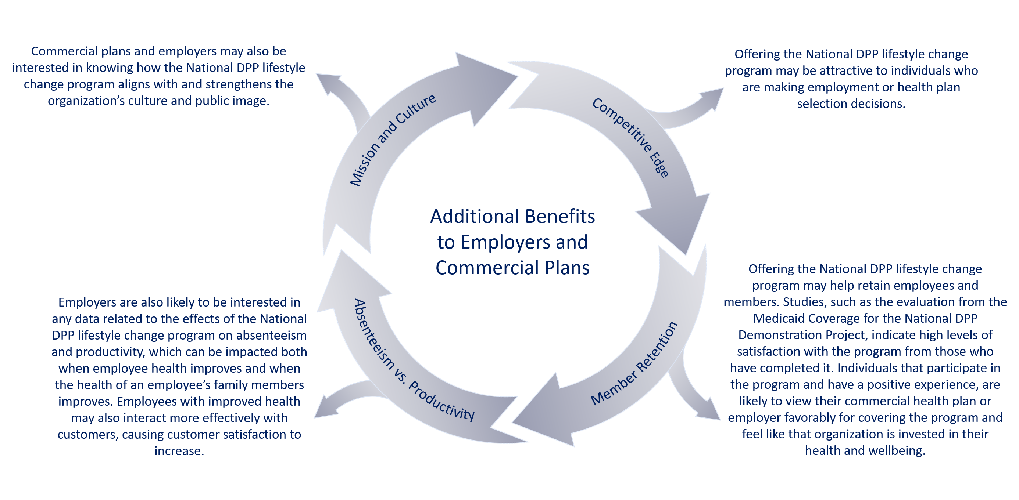

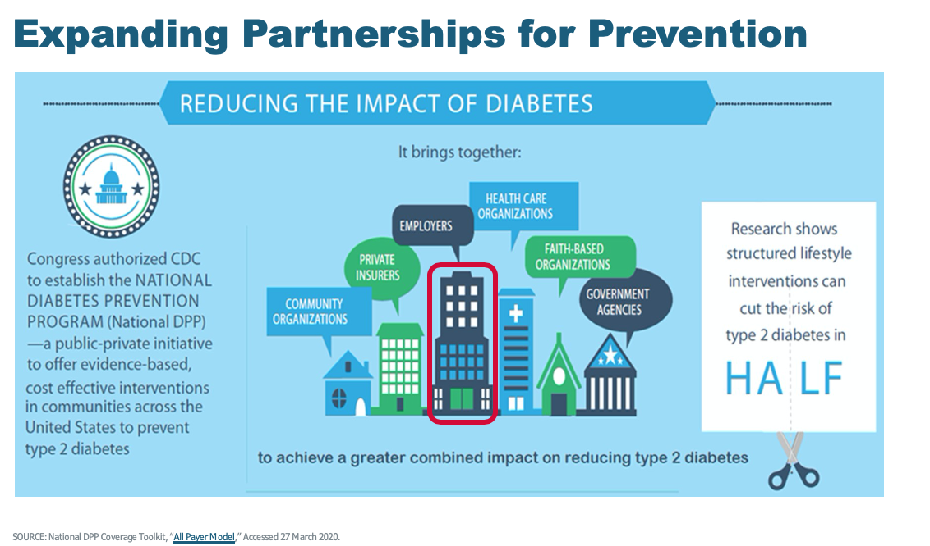

Slides 12-14: Examples and Testimonials

To-Do
- Insert examples of like organizations and/or testimonials from like organizations/participants

Additional Resources for Examples and Testimonials
Experiences from other commercial plans and employers offering the National DPP lifestyle change program can be found on the Coverage in Practice page of the Coverage Toolkit, including a video of testimonials from Costco employees who participated in the program.
Look at the Participating Payers page to see various organizations that cover the National DPP program. Consider reaching out to an organization that is a similar industry type, size, and/or location to see if they have suggestions.
Written and video testimonials from former program participants can be found on the CDC National DPP website.

Slides 15-17: What Can You Do? (Employer Template Slides 15-16; Commercial Template Slides 15-17)

Additional Information and Statistics for “What Can You Do?”
- Consider next steps, such as:
  - How can an organization initiate planning or expand efforts for establishing coverage of the program?
  - Who will be the point person for this work?
  - What additional information is needed and who needs it to make the ultimate “go or no go” decision to roll out coverage?
  - What is a reasonable timeline for rolling out coverage?
  - What other resources are available?

Additional Resources for “What Can You Do?”
Visit the Case for Coverage page to fill out the Readiness Assessment, and review the Barriers to Coverage FAQ document and the Pathways to Coverage document for next steps.
Visit the Cost and Value page of the Coverage Toolkit for more tools and resources related to calculating the ROI and VOI and budgeting the program.
The Participating Payers page of the Coverage Toolkit provides a list of payers who are currently covering the National DPP lifestyle change program, including commercial health plans, employers, state-public employee coverage, state Medicaid coverage, and Medicare coverage. The page contains multiple visuals and maps that can be copied into a presentation.
The Coverage in Practice page of the Coverage Toolkit contains case studies of employers and commercial plans covering the program.
CDC has created the following customizable templates to make it quick and easy for employers or members to outreach to employees about the National DPP lifestyle change program.
- Email Template - This email template is for employers or insurers to email employees or members to encourage them to get tested for prediabetes and enroll in a program if eligible. It could be used for initial outreach or tailored for use during National Diabetes Month and Diabetes Alert Day.
- Promotional Images – These images can be added to emails, presentations, intranet or social media posts, or other communications about the National DPP lifestyle change program. They also can be printed as postcards and mailed to employees or members.
- Fact Sheet Template – This fact sheet is a one-page document for employees or members on prediabetes, the National DPP lifestyle change program, and enrollment.
- Workplace Poster Template ((24” x 36”) – This poster encourages employees to seek more information on available lifestyle change programs and to find out if they are eligible. It is meant to be posted in a common area.
Additional promotional materials for recruiting program participants created by CDC can be found here, and the “Do I Have Prediabetes?” ad campaign can be found here.
The Recruitment and Referral page of the Coverage Toolkit contains examples of how organizations have outreached to members or employees.

Additional Graphics for “What Can You Do?”
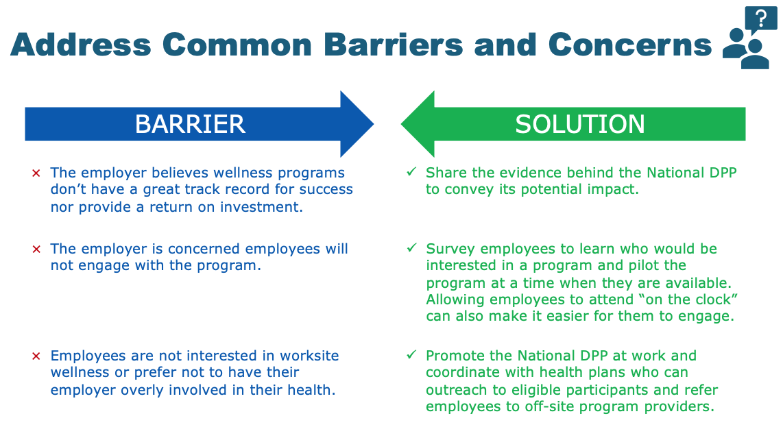
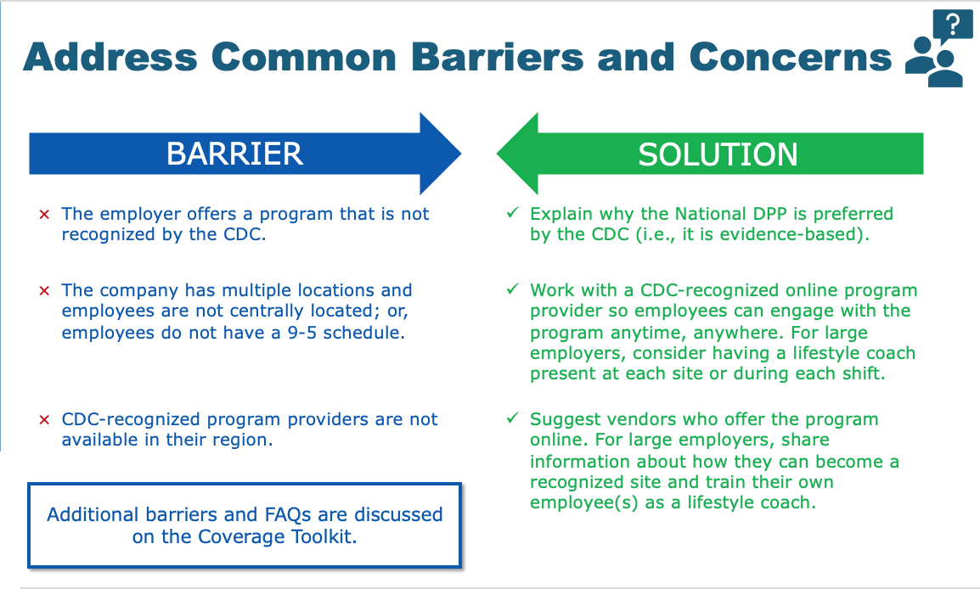
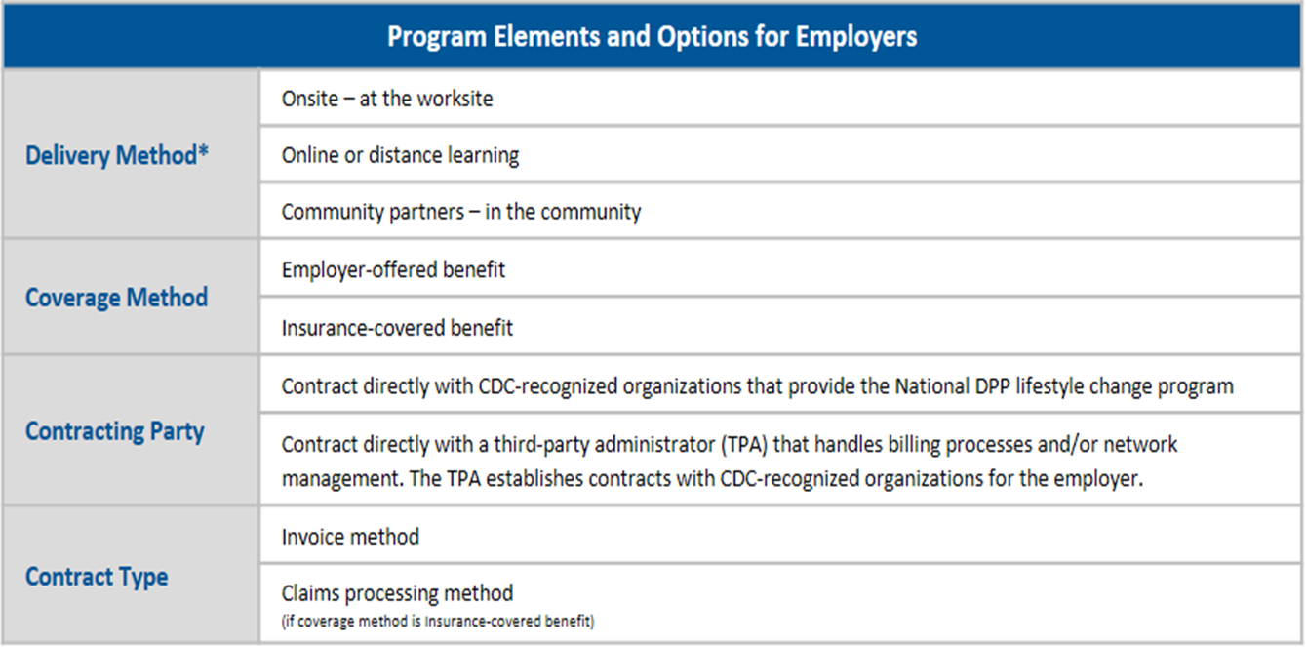

Slides 17-20: For More Information, Questions, and Sources Cited (Employer Template Slide 17-19; Commercial Template Slide 18-20)

To-Do
- Insert contact information

Presentation Tips
This is a great opportunity to answer any questions and reaffirm next steps.

__________________________________________________________________
Please contact us with any questions about the content on the Coverage Toolkit at coveragetoolkit@chronicdisease.org.

Boyle Jp, Thompson Jt, Gregg Ew, Et Al. Projections of the Year 2050 Burden of Diabetes in the US Adult Population: Dynamic Modeling of Incidence, Mortality, and Prediabetes Prevalence. Popul Health Metr 2010;8:1–29.
Dieleman JL, Baral R, Birger Ml, et al. U.S. spending on personal health care and public health, 1996–2013. JAMA. 2016;316:2627–2646.
American Diabetes Association. Economic costs of diabetes in the U.S. in 2017. Diabetes Care. 2018;41:917–928.
Bardenheier BH, Lin J, Zhuo X, et al. Disability-free life-years lost among adults aged ≥50 years, with and without diabetes. Diabetes Care. 2016;39:1222–1229.

